MTH 9879

**Lecture 1**

1. Market order may be executed by a much less price then what you excepted. Therefore send limited order to sell.

2. Exchange (e.g. NYSE) make money by selling data. (High frequency trader make money through the big data)

3. Marketable limit order: Price does not crash (e.g. From 40 to 1 cent)

4. Rebate fee (transaction fee) of hidden order is cheaper (?) then the visible orders

5. ISE: international stock exchange

6. Batch Auction: Opening auction 9am Closing auction 4pm in NYSE

7. Dark pools traded with mid-price (However there are sharks in the dark pools); No dark pools in the bank

8. BATS: better alternative trading system

9. People split orders, not put all shares one time

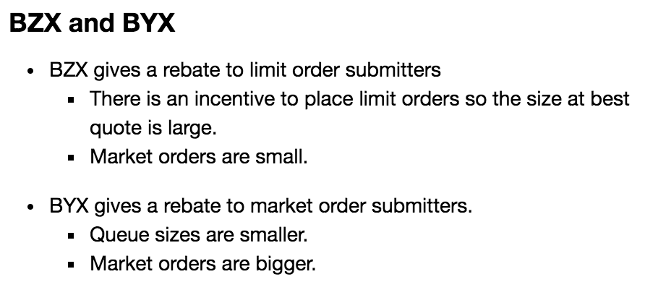

10. Histogram of Spread: multiple ticks -> small tick stock; one tick -> large tick stock

11. Order leaving: cancelled (because no market orders)

12. Order (sequence) of the event is critical important

12.1 order depth: d (in the lecture ipython notebook)

13. Dimension are same as **Unit**

|  |  |
| --- | --- |
| Parameter | Dimensions |
| mu | #/T **T: unit time** |
| alpha | #/ticks/T  **ticks: dollar** |
| delta | 1/T |

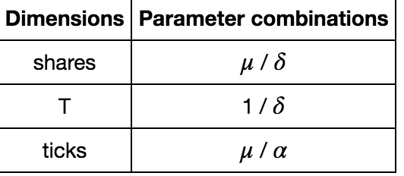

14. Slope: using delta change in vertical over delta horizon (half spread)

15. Implementation: make infinity as 30 or 20

16. Micro price: like fair price

17. R: <<- : global variable; <- : local variable

18. Bid-ask: **an immediate sale (bid) and an immediate purchase (offer) for stocks**

19. If spread of a stock is big, people are going to put more hidden order (indicator large H)

20. People cancel ahead of you in the queue, it is better to cancel the limit order either

**Lecture 2**

1. Table IV: diagonal effect: If there is a buy, there might be a following buy

2. C2: consumption on Day 2

3. B: get cash today,  deliver stock tomorrow.  means: utility increases

4. put market sell, price goes down

5. Reality between ZI model and efficient markets model

6. Impatient trader: sent market order, no need to wait

7. lambda: order arrive rate

8. “Bible”: How markets slowly digest changes in supply and demand

**Rosu Model**

Clever point:

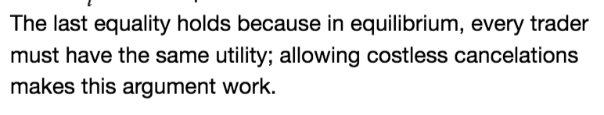

9. In reality: trader submits fleeting limit orders because of latency arbitrage (guarantee profit)

**Cont and Kukanov model**

10. Explanation:

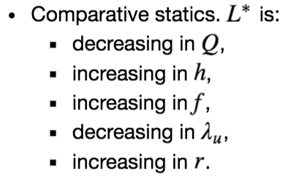

The higher spread h, the higher L_star

11. Good model for trader how to optimize order placement

**BMP model**

**Market Liquidity Chapter 1**

1. one difference between limit and market orders is that limit orders do not guarantee immediate execution—indeed, they may never be executed at all—whereas market orders are executed immediately upon submission.

2. This cost—the difference between the best bid and the best ask price on the market—is called the “quoted bid-ask spread” and is often used as a measure of illiquidity.

3. For larger orders, one can compute a similar measure of illiquidity by comparing the average price paid by a buyer placing a large market order and the average price received by a seller for an equally large order. The buy price rises with order size, because the buyer has to “walk up” the schedule of sell limit orders to fill his own buy order. Symmetrically, the sell price is decreasing with the size of the order, as the seller has to “walk down” the schedule of buy limit orders. Thus larger orders are associated with a greater difference between the average execution price for buy and sell market orders—the “weighted average bid-ask spread.”

4. A market in which investors can trade large quantities without substantially moving the price—that is, where the weighted average bid-ask **(p.21)** spread does not increase much with trade size—is said to be “deep.”

5. *market depth* is inversely related to the weighted average spread for large trade size.

6. A stop sell order can be used to limit one’s losses on holding a stock if its price nosedives.

7. Call auctions are used as the only trading mechanism for stocks that are traded infrequently

8. Two segments in dealer market: the retail segment: which dealers serve final investors,

and the wholesale segment (interdealer market): dealers trade with each other to share inventory risk.

9. Unlike limit order markets, dealer markets often enable traders to bargain over price and quantity

**10. Broker VS dealer**

Bear in mind that dealers differ from brokers. Brokers (such as Charles Schwab in the United States) only execute buy or sell orders of final investors (indifferently in dealer or limit order markets), but they do not act as counterparties for these orders. Dealers, instead, are the counterparties to final investors and so take inventory risk. Some securities firms (e.g., Goldman Sachs or Merrill Lynch) offer both services to their clients, and are accordingly known as broker-dealers.

**Common:** common is that both help final investors to carry out their trades. For this reason, brokers and dealers are often collectively referred to as the “sell side” of the securities industry, whereas final investors (households, institutional investors, firms, and government) are called the “buy side” (since they buy trading services from the sell side)

11. Market transparency: transparency depends not only on the availability but also the cost of information.

12. In general, electronic limit order markets tend to be very transparent

13. a market is efficient if it enables investors to trade quickly and cheaply (i.e., if it is liquid) and if it incorporates new information quickly and accurately into prices.

14. Trading platform revenue resources: listing fees ( who list their shares on the exchange) and the sale of market data, such as real-time quotes. Also trading volume (trading revenue)

**HW 1 R code question**

See the HW1_code_paradox.R in the github repo

**Lecture 3**

**Garman model**

1. Choice price: bid and ask price are the same (cross point of supply and demand lines)

2. Two-way price: bid-ask, including spread

**Amihud and Mendelson model**

**1.**

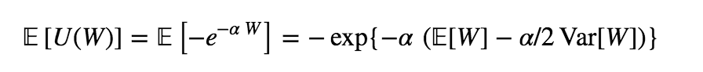

W is normal distributed.

2. Maximize the CARA utility is equivalent to maximizing mean-variance optimization (**TEST**)

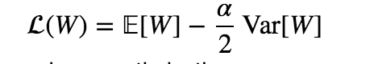

**Stoll model**

1. Spread is quadratic in volatility: is not make sense

In S&P500, gold has negative correlation with other stocks. All others have the same direction (positive correlation)

2. In reality, the spread does not correlate with the quote size too much.

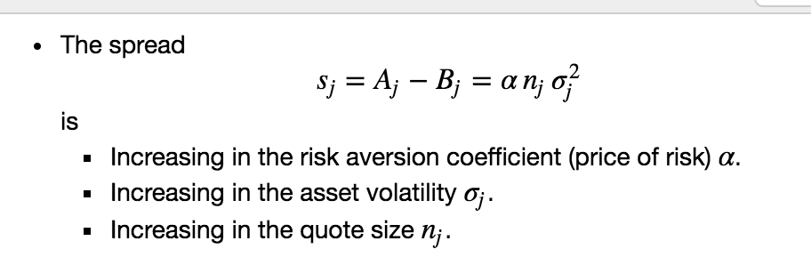

3. 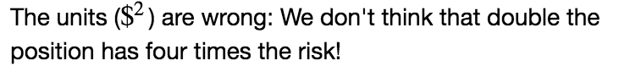

The risk: lose money, the quantity/unit is dollar, not dollar square

4. : nu

**Monetary risk measures**

1. Cash invariance: m: cash

**Ho and Stoll model**

1. admissible controls: every allowed controls/actions

2. Market impact in this model

3. HJB

Bid hit: cash goes down, inventory goes up

Ask hit: cash goes up, inventory goes down

